RESUME
- Problem Solver
- Orator
- Quick Learner
- Optimist

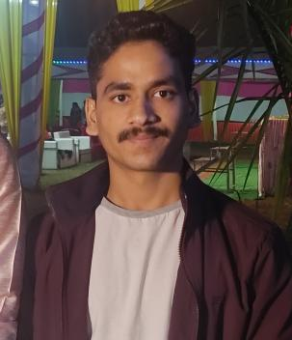
Sushant Sharma
81 Manpur
Colonel House, Maihar, MP
6264645224
sushantsharmadev@gmail.com

Career Objective: A passionate fresher to work where performance is rewarded with new responsibilities and knowledge to grow along with the organization.

Personal Qualification: B-tech in Computer Science Medi-Caps University CGPA 9.47(till 3rd SEM)

Educational Qualification:

- 12thfrom CBSE Board Army Public School Mhow, MP 81%
- 10thfrom CBSE Board Army Public School Mhow, MP 87.6%

Technical Skills:

- Language: C, C++, HTML 5, CSS 3, JAVA SCRIPT, MySQL, JAVA
- Tools : GITHUB, VS CODE, TAILWIND CSS, FIREBASE

Certifications:
- C, C++ - Univarsal infomatics,Bhawarkua,Indore
- Cyber security and Ethical Hacking – Udemy
- HTML 5, CSS 3
- Java Script -Udemy
Project:
- Personal portfolio.
Link: https://sushantsharmadev.com
- Flappy Bird Game Logic.
Link: https://flappy-bird-six.vercel.app/

- Visualiser for Search Algorithms
Link: https://sushantsharma08.github.io/Search_Algorithm/index.html
- Ambigrams
Link: https://ambigram-stuff-shailscript.vercel.app/

Extra Circular Activities:

- Cultural: Debates, Event management.
- Sports: Basketball, Volleyball, Football, Swimming, Running, Cycling.

Achievements:

- Basketball School level
- Volleyball School level
Hobbies: Reading Poetries, listening songs, learning about outer space, Basketball, Running and Swimming.
Strength and Weakness: Optimistic and Single mindedness.

Personal Details:

- Date of Birth: 08 December 2002
- Gender: Male
- Nationality: Indian
- Marital status: Unmarried
- Language known: English and Hindi
- Passport detail: Yes

Date: 14-04-2022
Place: Indore, MP

